# DECLARATION

I, **Kriti Arora**, hereby state and affirm that the project titled **“Tranquil Trail”** which is submitted by me to the Department of Computer Science and Engineering, Amity School of Engineering Technology, Amity University Uttar Pradesh, Noida is my original work.

I confirm that the content, findings, and conclusions presented in this project are based on my own research, analysis, and understanding.

I further declare that this project has not been previously submitted for the purpose of obtaining any degree, diploma, or similar recognition. It is a unique contribution that has not formed the basis for any other academic qualification or professional achievement.

**DATE:** 08/07/24

**NAME:** Kriti Arora **ENROLLMENT:** A2305222491

**SECTION:** 5-CSE 8X

# CERTIFICATE

On the basis of the report submitted by **Kriti Arora (A2305222491)**, a student of Bachelors of Technology in Computer Science and Engineering, I hereby certify that the project titled **“Tranquil Trail”** which is submitted to the Department of Computer Science and Engineering, Amity University, Noida, Uttar Pradesh, in partial fulfilment of the requirements for the award of the Degree of Bachelor of Technology in Computer Science and Engineering, is an original contribution to the existing knowledge and a faithful record of work carried out by her under my guidance and supervision. To the best of my knowledge, this work has not been submitted in part or full for any degree or diploma to this university or anywhere else.

**Date:** 08/07/24 **Place:** Noida

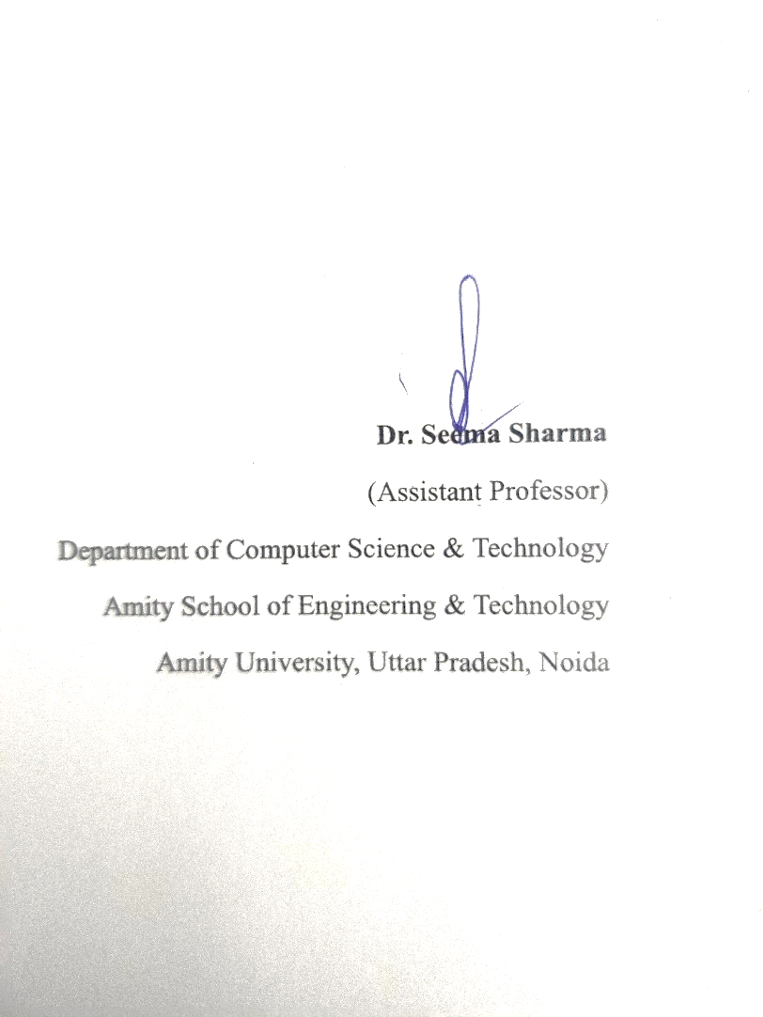

# 

# ACKNOWLEDGEMENT

# I would like to express my deepest gratitude and appreciation to all those who have contributed to the successful completion of this project on Tranquil Trails: LLM model. Their support, guidance, and assistance have been invaluable throughout the Project.

# First and foremost, I am immensely grateful to my faculty guide, Dr Seema Sharma, whose expertise, encouragement, and insightful feedback played a vital role in shaping this report. Your guidance helped me navigate through the vast landscape of LLM technology, and your constant support motivated me to push my boundaries and deliver a comprehensive analysis.

# 

# I am also thankful to the numerous experts, professionals, and researchers in the field of Artificial Intelligence and Machine Learning who generously shared their knowledge and experiences. Their insights and perspectives were invaluable in gaining a proper understanding of the industry and its potential applications. I am also grateful to my parents, friends and colleagues for their support and encouragement throughout this research endeavour. I also appreciate their effort in filling the survey form for the comparisons and compilation of my research result.

KRITI ARORA

# 

# ABSTRACT

The aim of the Tranquil Trails project is to create a specialised Large Language Model (LLM) that will provide interactive, personalised services for travellers seeking peace and well-being. This LLM will be trained on large datasets using deep learning techniques in order to produce human-like text interpretation and guidance for users regarding spiritual locations, mindful dining experiences, and wellness activities.

The project focuses on using specific datasets that are adjusted to make the LLM better at understanding and giving accurate advice. This customization makes the AI more useful for travellers looking for spiritual and wellness experiences, setting new standards for how AI can help in travel, especially in spiritual tourism.

The project explores the capabilities of text generation through pre-trained language models, emphasising the integration of custom datasets to enhance the LLM’s performance in delivering relevant and enriching content. This project is focused on investigating how adjusted datasets may be used to improve language models and generate text that is human-like and contextually accurate, expanding the range of possible uses in the social, intellectual, and commercial spheres. Thus, Tranquil Trails ultimate goal is to set new standards for interactive AI in the domain of spiritual tourism.

# CONTENTS

**DECLARATION** **i**

**ACKNOWLEDGEMENT** **ii**

**CERTIFICATE** **iii**

**ABSTRACT** **iv**

**CONTENTS** **v**

**LIST OF FIGURES** **vi**

**CHAPTER 1**: **INTRODUCTION 1****-4**

1.1 Introduction 1

1.2 Objective 1

1.3 Scope 2

1.4 Report Structure 3

**CHAPTER 2**: **LITERATURE REVIEW** **5-9**

2.1 Natural Language Processing 5

2.2 Large Language Models 5

2.3 LangChain 5

2.4 GoogleGenerativeAIEmbeddings 6

2.5 RetrivalQA 6

2.6 FAISS 7

2.7 Prompt-template 8

2.8 StreamLit 8

**CHAPTER 3**: **METHODOLOGY 1****0-25**

3.1 Weekly Flow Chart 10

3.2 Dataset 13

3.3 Code 16

3.4 Steps 23

**CHAPTER 4**: **RESULT AND DISCUSSION** **26-29**

4.1 RESULT 26

4.2 DISCUSSION 29

**CHAPTER 5**: **CONCLUSION AND FUTURE ADVANCEMENTS** **31-32**

5.1 Future Advancements 31

5.2 Conclusion 32

**REFERENCES** **33**

# 

# LIST OF FIGURES

|  |  |  |
| --- | --- | --- |
| **FIGURE NO.** | **FIGURE DETAILS** | **PAGE NO.** |
| 3.1.1 | WEEKLY FLOWCHART: WEEK-1 | 10 |
| 3.1.2 | WEEKLY FLOWCHART: WEEK-2 | 10 |
| 3.1.3 | WEEKLY FLOWCHART: WEEK-3 | 11 |
| 3.1.4 | WEEKLY FLOWCHART: WEEK-4 | 11 |
| 3.1.5 | WEEKLY FLOWCHART: WEEK-5 | 12 |
| 3.1.6 | WEEKLY FLOWCHART: WEEK-6 | 12 |
| 3.1.7 | WEEKLY FLOWCHART: WEEK-7 | 13 |
| 3.2.1 | DATASET-1 | 15 |
| 3.2.2 | DATASET-2 | 16 |
| 3.2.3 | DATASET-3 | 16 |
| 4.1.1 | OUTPUT-1 | 26 |
| 4.1.2 | OUTPUT-2 | 27 |
| 4.1.3 | OUTPUT-3 | 27 |
| 4.1.4 | OUTPUT-4 | 27 |
| 4.1.5 | OUTPUT-5 | 28 |
| 4.1.6 | OUTPUT-6 | 28 |
| 4.1.7 | OUTPUT-7 | 28 |
| 4.1.8 | OUTPUT-8 | 29 |
| 4.1.9 | OUTPUT-9 | 29 |

# 